1. ls

The ls command - the list command - functions in the Linux terminal to show all of the major directories filed under a given file system. For example, the command:

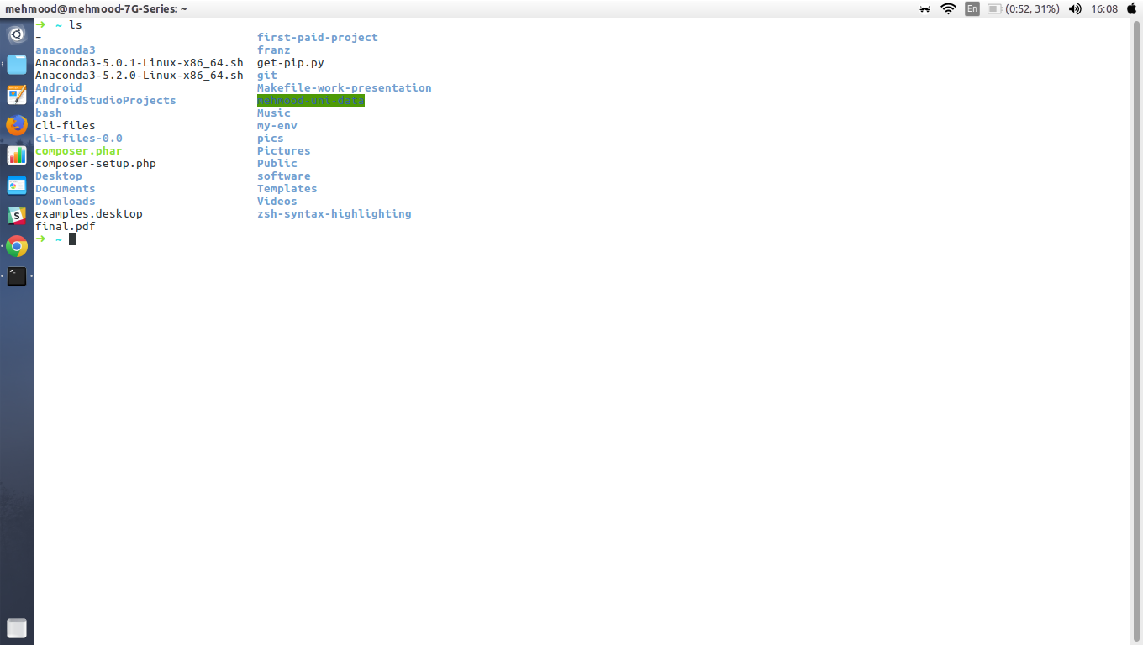
The ls command is used for viewing files, folders and directories.

2. cd
The cd command - change directory - will allow the user to change between file directories. As the name command name suggest, you would use the cd command to circulate between two different directories.
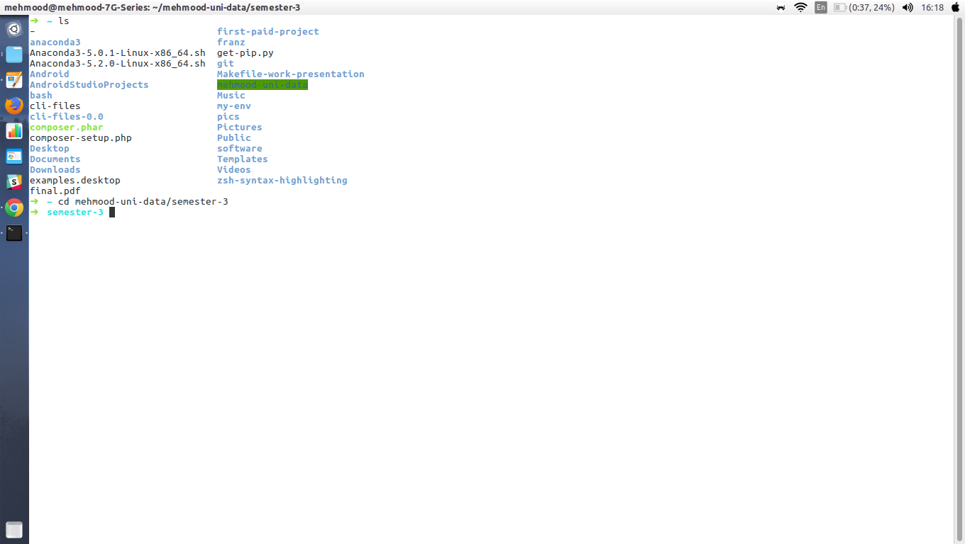

3. mv

The mv command - move - allows a user to move a file to another folder or directory. Just like dragging a file located on a PC desktop to a folder stored within the "Documents" folder, the mv command functions in the same manner. An example of the mv command is:

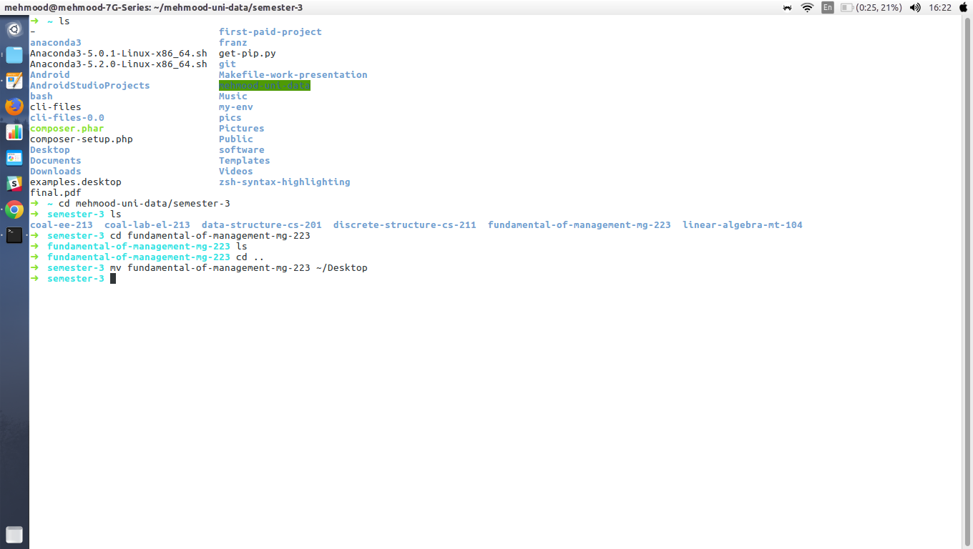

4. man

The man command - the manual command - is used to show the manual of the inputted command.Inputting the man command will show you all information about the command you are using. An example:

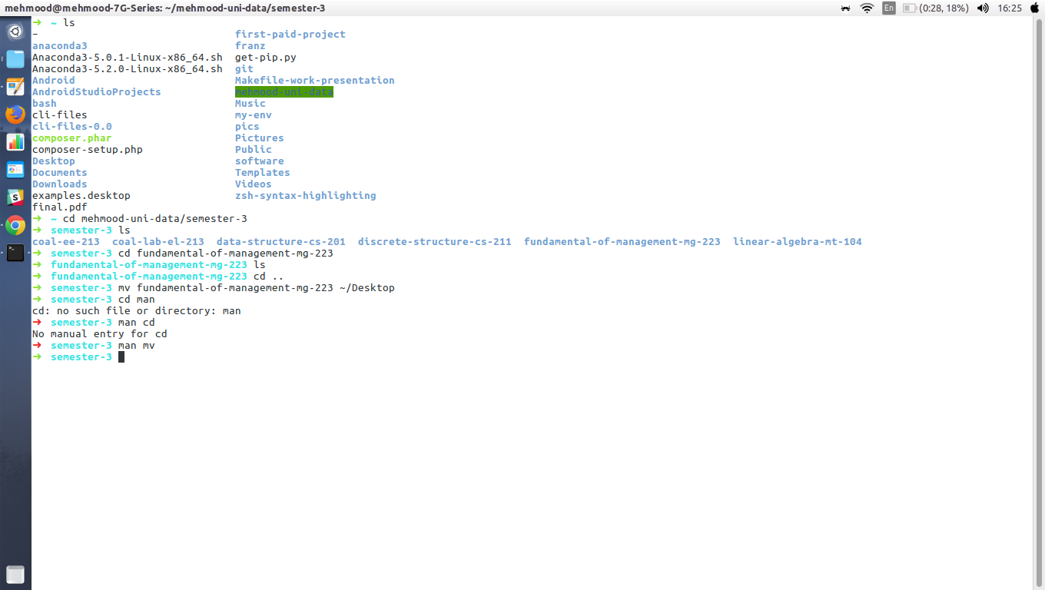

5. mkdir

The mkdir - make directory - command allows the user to make a new directory. Just like making a new directory within a PC or Mac desktop environment, the mkdir command makes new directories in a Linux environment. An example of the mkdir command:

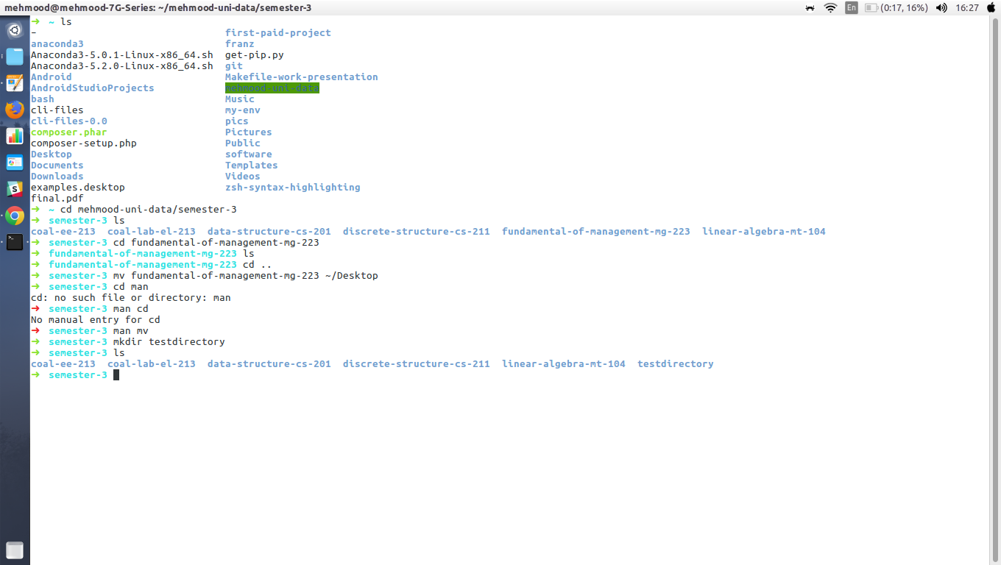

6. rmdir

The rmdir - remove directory - command allows the user to remove an existing command using the Linux CLI. An example of the rmdir command:

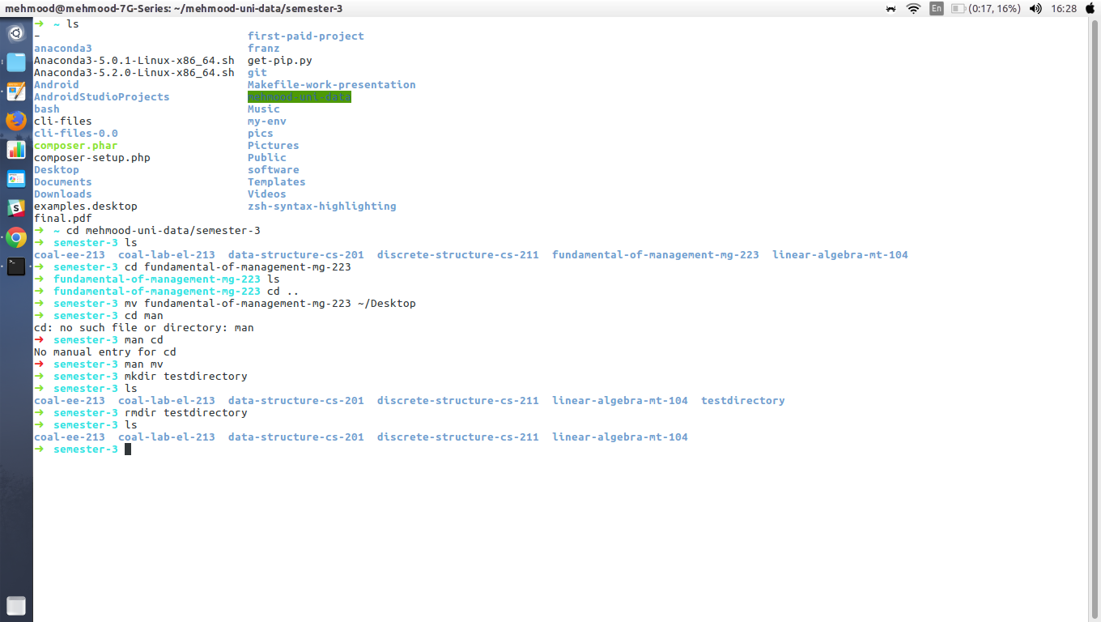

7. touch

The touch command - a.k.a. the make file command - allows users to make files using the Linux CLI. Just as the mkdir command makes directories, the touch command makes files. Just as you would make a .doc or a .txt using a PC desktop, the touch command makes empty files. An example of the touch command:

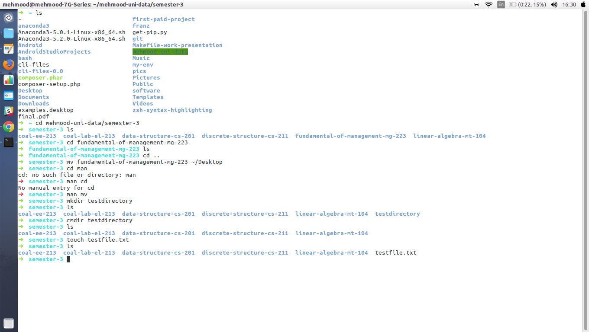

8. rm

The rm command - remove - like the rmdir command is meant to remove files from your Linux OS. Whereas the rmdir command will remove directories and files held within, the rm command will delete created files. An example of the rm command:

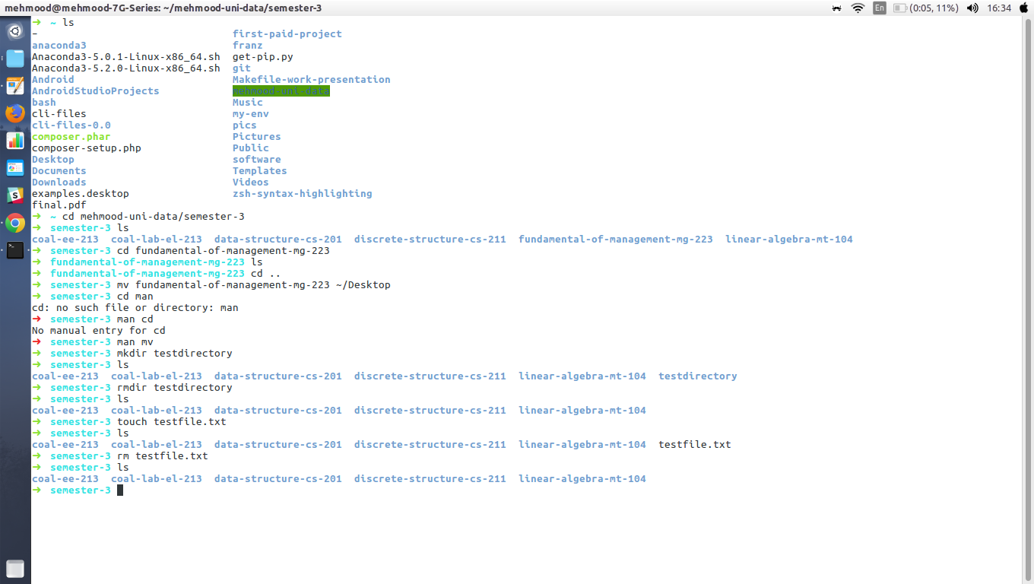

9. clear

The clear command does exactly what it says. When your Linux CLI gets all mucked up with various readouts and information, the clear command clears the screen and wipes the board clean.
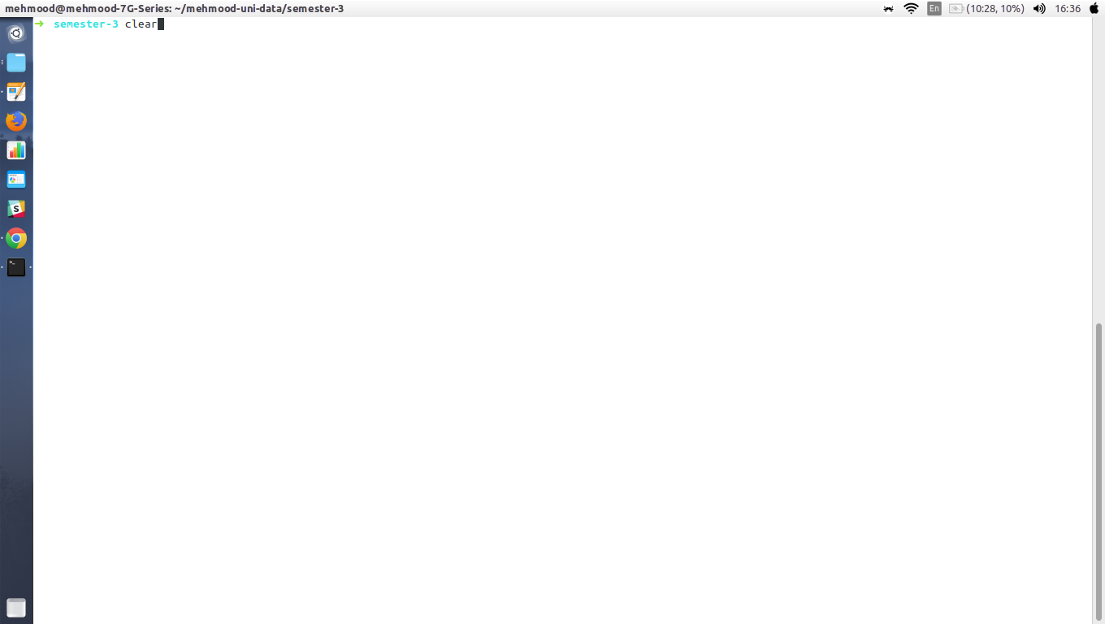

10. Uptime
In Linux uptime command shows since how long your system is running and the number of users are currently logged in and also displays load average for 1,5 and15 minutes intervals.
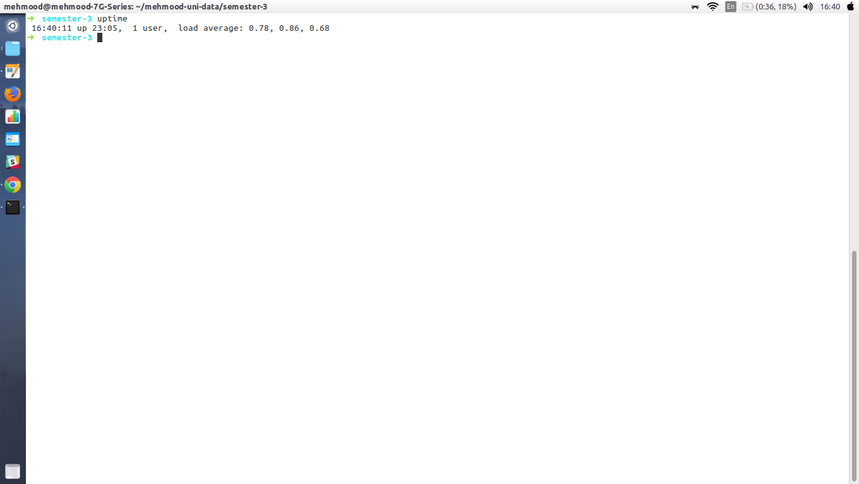

11. W Command
It will displays users currently logged in and their process along-with shows load averages. also shows the login name,tty name,remote host, login time, idle time, JCPU, PCPU, command and processes.

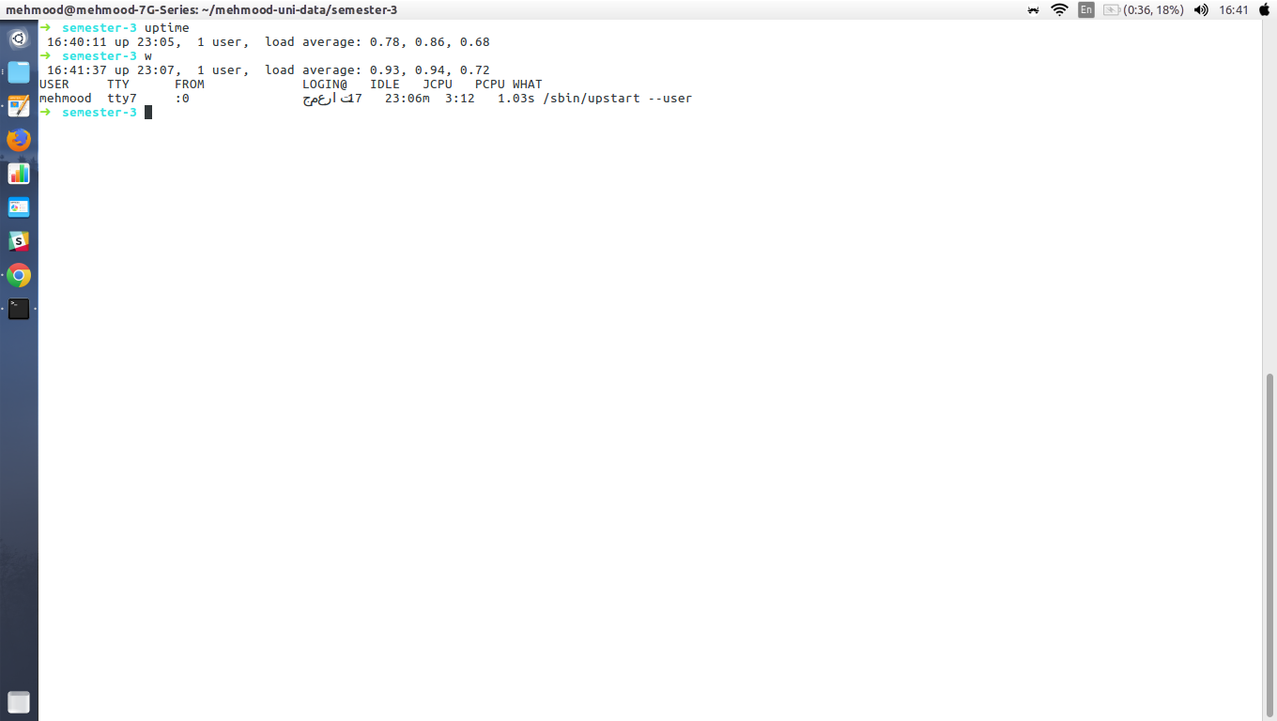

12. Users Command
Users command displays currently logged in users. This command don’t have other parameters other than help and version.

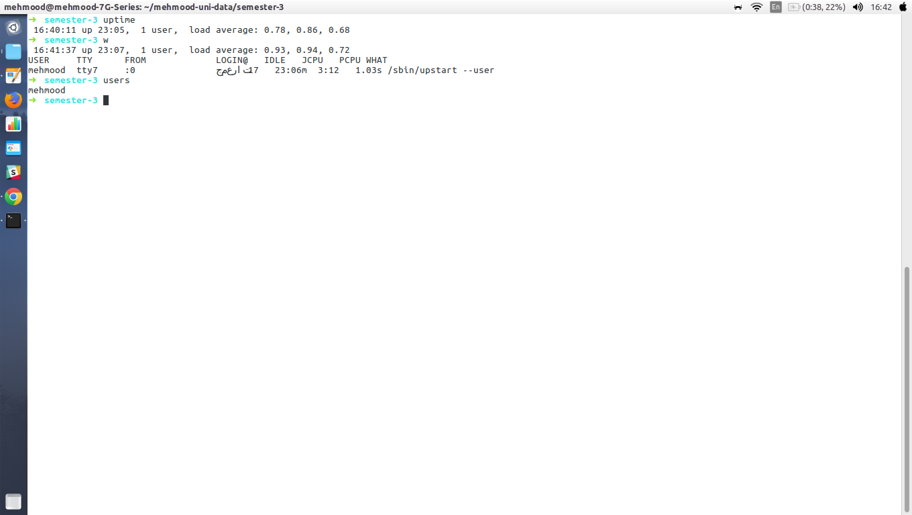

13. Who Command
who command simply return user name, date, time and host information. who command is similar to wcommand. Unlike w command who doesn’t print what users are doing. Lets illustrate and see the different between who and w commands.
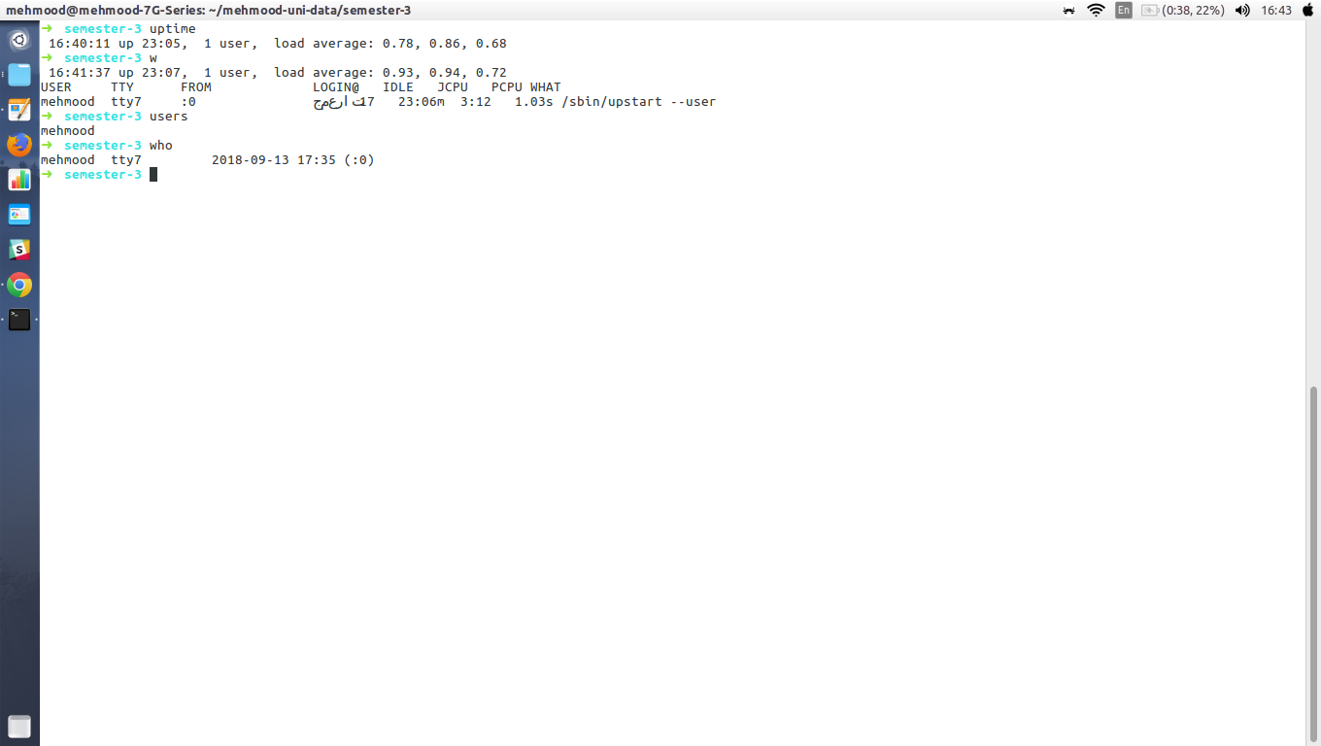

14. Whoami Command
whoami command print the name of current user. You can also use “who am i” command to display the current user. If you are logged in as a root using sudo command “whoami” command return root as current user. Use “who am i” command if you want to know the exact user logged in.

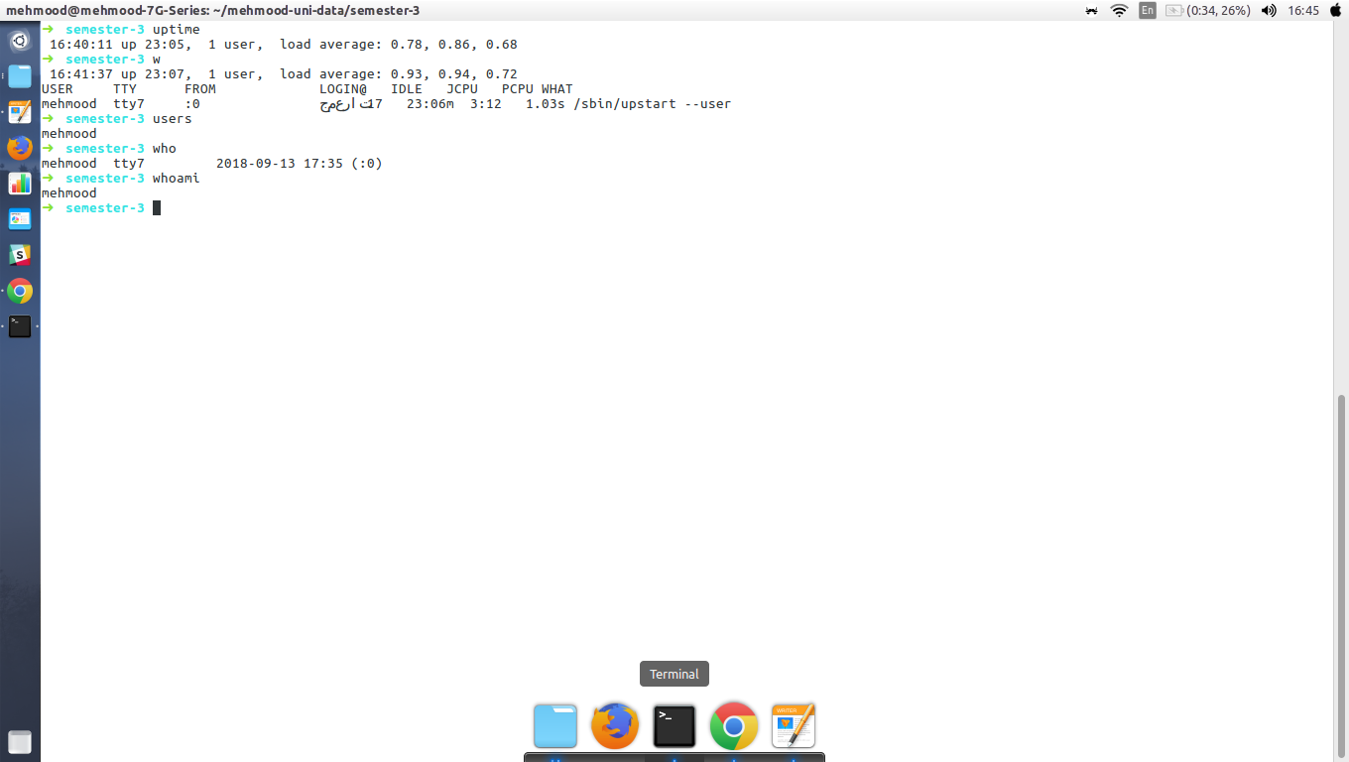

15: Cat Command
cat command used to view multiple file at the same time.
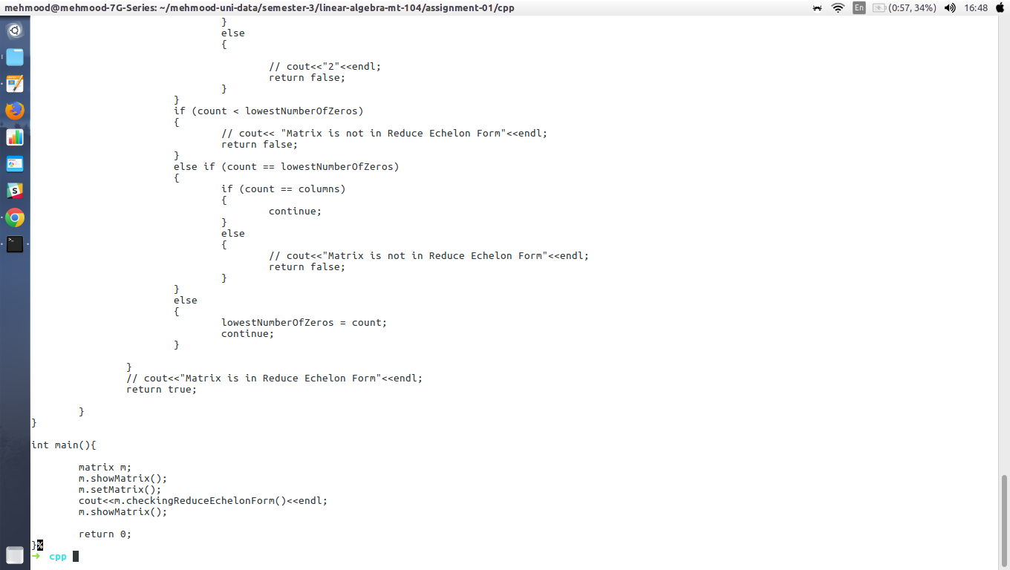

16:pwd command (print working directory)
pwd command return with present working directory.

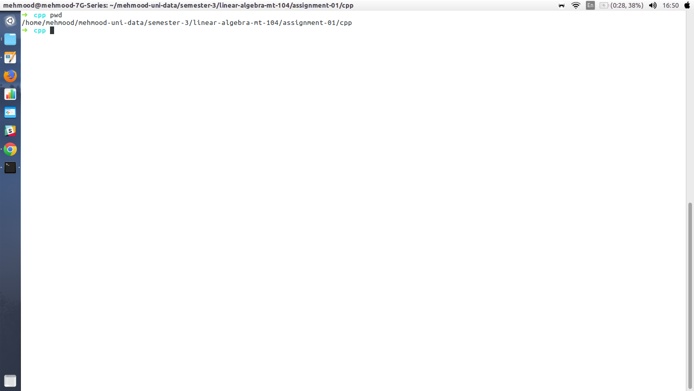

17:which Command
